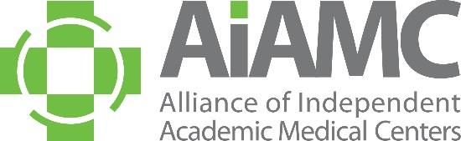

ALLIANCE OF INDEPENDENT
ACADEMIC MEDICAL CENTERS
2026 Annual Meeting
Special Call for Poster Abstracts

Residents and fellows from AIAMC-member institutions are invited to submit abstracts for poster presentation at the AIAMC 2026 AIAMC Annual Meeting, to be held April 16th – 18th at the Omni La Costa Resort and Spa in Carlsbad, California.

Abstracts are due no later than January 15, 2026, and all submitting authors will be notified of the committee’s selections in early February.

Criteria for Selection:
- Introduction: clearly articulated context for project or research study, including relevant literature
- Hypothesis/Aim Statement: clearly stated purpose of the project or research study
- Methods: clear description of how the project was conducted and/or implemented, with sound and appropriate project design
- Results: clear and unambiguous statement of what changed and how
- Conclusions: implications of the project beyond the local setting
All accepted poster presenters are required to register for the conference at the discounted resident rate of $300.00. Please do NOT submit an abstract if your attendance at the Annual Meeting is questionable. Accepted posters will be on display for the entire conference, i.e., from Thursday, April 16th through Saturday, April 18th. A staffed poster display will take place on Saturday, April 18th from 8:15 am – 8:45 am and submitting authors or their designees must stand by their posters during this time. Poster presenters are asked to make travel plans accordingly. In accordance with AIAMC policy, all registration fees and travel expenses will be the responsibility of the poster presenter’s home institution. Submitting an abstract is a commitment that, if the abstract is accepted, all poster presenters will attend the 2026 Annual Meeting and conduct sessions at the times assigned.
Poster Session Topics:
Session content should support the meeting theme of Anchored in Purpose: Leading through Uncertainty with Compassion and Courage in one of the following content areas:

- Advocacy
- Immigration
- Purpose-Driven Leadership
- Resilience in Times of Disruption
- Innovative Approaches to Medical Education

Poster Display Information:
A suggested PowerPoint template of the poster will be emailed to all selected candidates. The poster board surface must be 42” wide by 30” high (landscape orientation). Poster displays will be assembled on Thursday, April 16th between 8:00 a.m. and 11:00 a.m. They will remain on display throughout the Annual Meeting and National Initiative X Meeting Two, which concludes at 12:00 noon on Saturday, April 18th. Any posters not removed at the conclusion of the meetings will be discarded by the hotel staff.
We encourage you to submit an abstract and look forward to seeing you at the meeting!

